MAC and IP

Destination on Same Network

**There are 2 primary addresses assigned to a device on an ethernet LAN:**

PHYSICAL ADDRESS (MAC address)

- used for NIC-to-NIC communication on the same Ethernet Network

LOGICAL ADDRESS (IP address)

- used to send the packet from the source device to the destination device

Layer 2 physical addresses   
 are used to deliver date link frame with the encapsulated IP packet from one NIC to another NIC that is on the same network

If the destination IP address is on the same network, the MAC address will be that of the destination device  
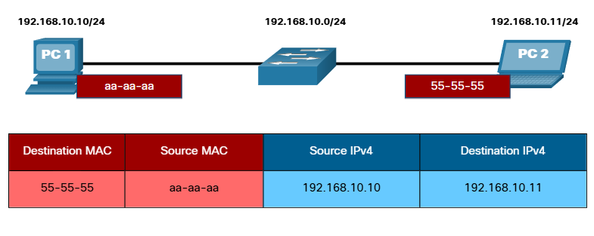

PC1 wants to send a packet to PC2. the figure displays the layer 2 destination and source MAC addresses and the layer 3 IPv4 addressing that would be included in the packet sent from PC1

**Layer 2 Ethernet frame contains the following:**

DESTINATION MAC ADDRESS

- from example 55-55-55

SOURCE MAC ADDRESS

- from example aa-aa-aa

**Layer 3 IP packet contains the following:**

SOURCE IPv4 ADDRESS

- from example 192.168.10.10

DESTINATION IPv4 ADDRESS

- from example 192.168.10.11

Destination on remote network

When the destination IP address is on remote network, the destination MAC address will be the address of the host default gateway

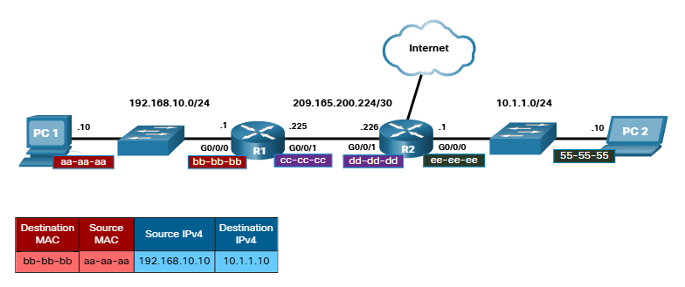

PC1 wants to send a packet to PC2. PC2 is located on remote network

Since the destination IPv4 address in not on the same local network as PC1, the destination MAC address is that of the local default gateway

Router examines the destination IPv4 address to determine the best path to forward the IPv4 packet

**When the router receives the ethernet frame, it de-encapsulates the layer 2 info.**

**Using the destination IPv4 address, it determines the next-top device, and then encapsulates the IPv4 packet in a new data link for the outgoing interface**

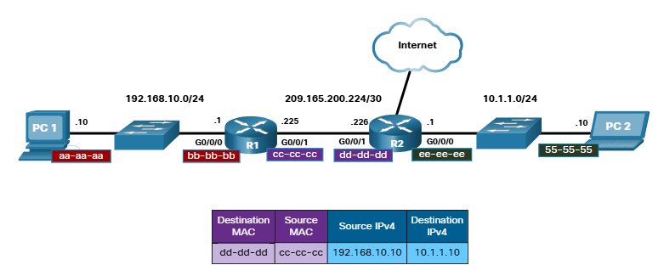

**The new destination MAC address would be that of the R2 G0/0/1 interface and the new source MAC address would be that of the R1 G0/0/1 internace**

Along each link in a path, an IP packet is encapsulated in a frame. The frame is specific to the data link technology that is associated with that link, such as Ethernet. If the next-hop device is the final destination, the destination MAC address will be that of the device Ethernet NIC, as shown in the figure

